2016 Children and Youth Issues Briefing 2016
Presenters & Panelists
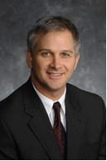 | Frank Forsberg, Senior Vice President  Greater Twin Cities United Way  Frank Forsberg is the Senior Vice President of Systems Change and Innovation. He oversees impact planning, public policy government relations, and external engagement. He came to United Way in December 1999, from Catholic Charities, where he was administrator of the Advocacy and Outreach Division. He has a bachelor’s degree in business from St. John’s University and a master’s degree in public administration from Hamline University. Frank also serves as the chair of the MinneMinds campaign which advocates for increased funding for early childhood initiatives in Minnesota.
Denise Mayotte, Executive Director
The Sheltering Arms Foundation

Denise Mayotte is the Executive Director of the Sheltering Arms Foundation and the co-chair of the Start Early Funders Coalition. Previously, Denise worked as a program officer for the arts at the McKnight Foundation and as the executive director of the Neighborhood Resource Center. She serves on the board of In Progress, a youth media organization, as Policy Committee Chair of the Strategic Leadership Team for Youth Community Connections in addition to numerous other civic and community leadership roles.
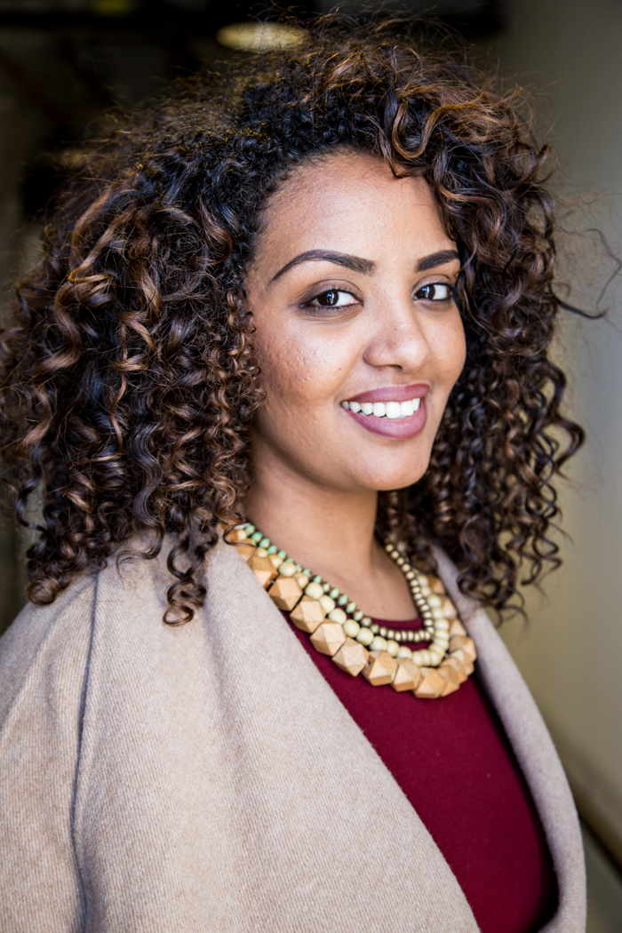 | Lulete Mola, Policy & Community Engagement Manager/McKinley Fellow  Greater Twin Cities United Way  Lulete Mola is the Policy and Community Engagement Manager and a Ron McKinley Philanthropy Fellow at Greater Twin Cities United Way. Born in Ethiopia, raised in Minnesota, Lulete is passionate about intersectional social justice and #BlackLivesMatter in the U.S. This passion directly contributes to her ongoing devotion to community organizing, most recently with VoteRunLead. Lulete is also the Founder of SHE, a young women’s leadership and power program in select Minnesota high schools. Lulete is a recipient of the Humanity in Action Fellowship, Ibrahim Leadership and Dialogue Project Fellowship and the Scholarly Excellence in Equity and Diversity Award. Lulete graduated summa cum laude from The University of Minnesota with a B.A. in Political Science and a minor in Family Violence Prevention.
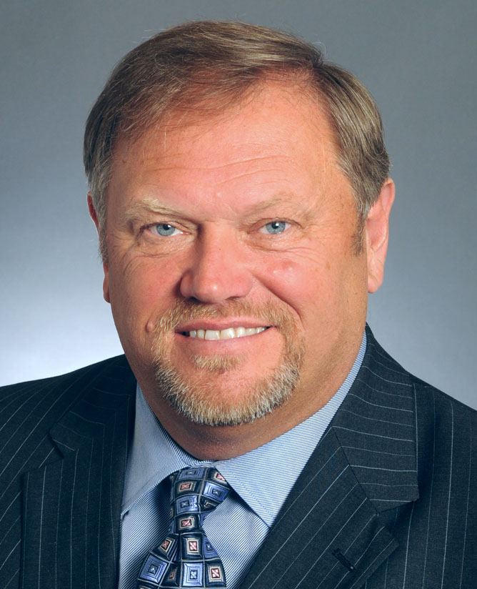 | Thomas Bakk, Majority Leader  Minnesota Senate  Thomas Bakk is a Minnesota politician and the Majority Leader of the Minnesota Senate. A member of the DFL Party, he represents District 3, which includes portions of Cook, Koochiching, Lake and St. Louis counties in the northeastern part of Minnesota. He is a retired labor official.
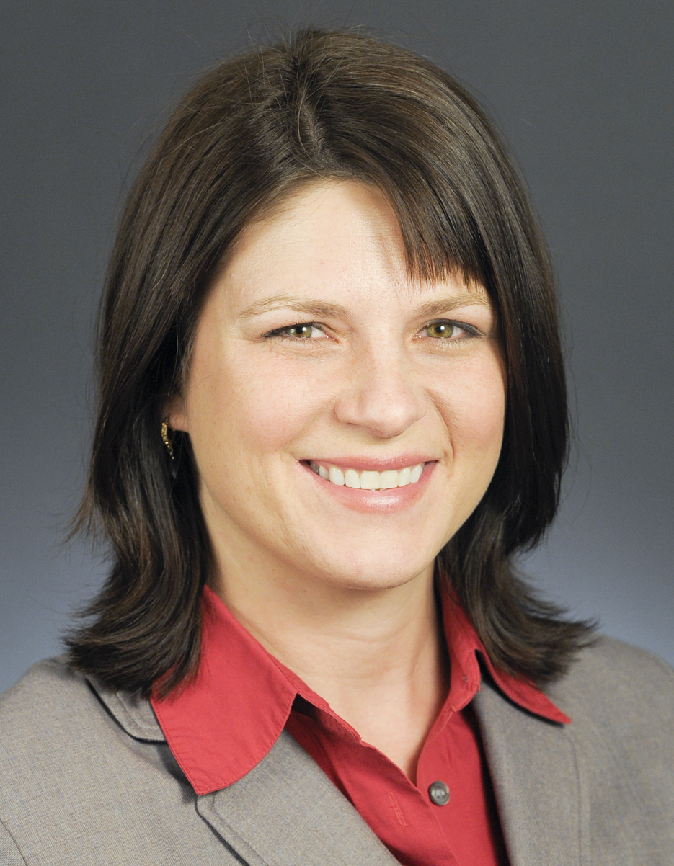 | Joyce Peppin, Majority Leader  Minnesota House of Representatives  Joyce J. Peppin is a Minnesota politician serving in her sixth term as a State Representative. A member of the Republican Party of Minnesota, she represents District 34A, which includes portions of Hennepin County in the northwestern Twin Cities metropolitan area. In 2015, Peppin became the Majority Leader of the Minnesota House of Representatives. She also is an attorney.
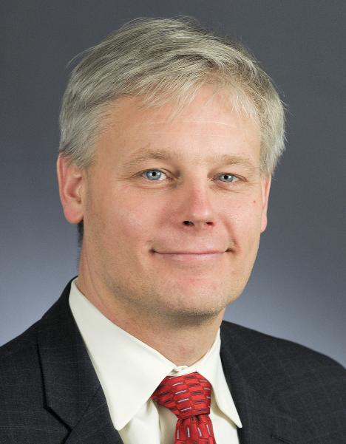 | Paul Thissen, Minority Leader  Minnesota House of Representatives  Paul Thissen is a Minnesota politician and the 58th Speaker of the Minnesota House of Representatives and current DFL Minority Leader. A member of the Minnesota Democratic-Farmer-Labor Party and serving in his seventh term, he represents District 61B, which is in south Minneapolis. First elected in 2002, Thissen has been reelected every two years since. He is also an attorney.
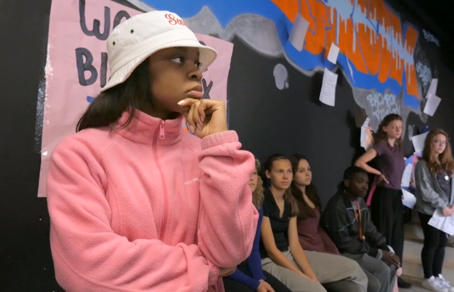 | Eshay Natreese, Artist  Eshay Natreese is a recent Washburn High School graduate, where she was well known for her artistic leadership and vision. During her time at Washburn, she acted as captain of the Hip Hop Dance Squad and toured with the Black Box Theater program. Eshay has participated in poetry 'slams' with TruArtSpeaks, done voice-overs for TPT, was cast as the lead mover for the music sensation Heiruspecs in there music video "On the Ground" making the City Pages Top Ten list. She directed For Colored Girls, with an all women of color cast. Eshay presented an original play she both wrote and directed at Patrick's Cabaret in 2014. She also starred in a documentary, called ‘’Believe in Black Youth;” a look into the lives of four black high school students and their personal thoughts on the education system. Eshay was also a production assistant and lobby specialist for U/G/L/Y at the Guthrie Theater(Fall of 2015). The show was written and performed by Sha Cage, whom Eshay first worked with after being cast in “The Blacker the Berry,” directed by Cage at Intermedia Arts. Eshay also enjoys participating in youth organizations, such as Young Life. She continues to be a bright voice for young artists in the Twin Cities.
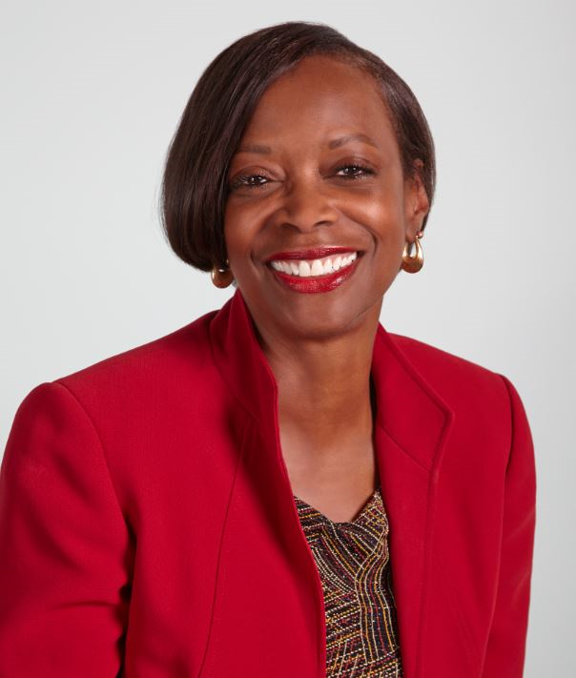 | Carolyn Smallwood, Executive Director  Way to Grow  Carolyn Smallwood has served the last 11 years as the executive Director of Way to Grow, Inc., an early education and elementary organization that serves over 2,300 people each year. Prior to Way to Grow, Ms. Smallwood served as Vice President for Sales and Marketing at Twin Cities Rise! She also served as the Executive Director of the Minnesota Minority Supplier Development Council.  In 2014, the Star Tribune named Carolyn one of the Twin Cities’ “Top African-Americans of Influence.” Ms. Smallwood currently sits on Governor Mark Dayton’s Early Learning Council and co-chairs Mayor Betsy Hodges Cradle to K cabinet; designed to eliminate disparities for children from prenatal to three years old in the City of Minneapolis. She also serves on the McPhail Center for Music board, the Robins, Kaplan, Miller, Ciresi foundation board, the African American Leadership Forum and MinneMinds Advisory Committee.  Throughout her career, she has spent her professional life advocating for the underserved and women Ms. Smallwood has a passion for work in diverse communities, a solid background in marketing, strong executive experience, an inclusive leadership style and a dynamic presence. She is strategic, thoughtful and recognizes that the education of children is a top priority.
Amber Stech, Parent Mentor
White Earth Child Care/Early Childhood Programs

Amber Stech was raised and has remained on the White Earth Reservation throughout her life. She is a mother of two wonderful children. Amber works as a Parent Mentor for the White Earth Reservation Child Care/Early Childhood Program. She has 4 years of experience working in Early Childhood Education. Amber enjoys helping educate children and giving them the experience they may not have received otherwise. She takes pride in what she does and believes that one positive in a child’s life can truly make a world of difference.
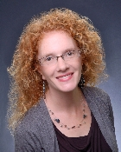 | Amanda Easty, Director  Hallelujah Child Care-Hermantown  Amanda has been the Director at Hallelujah Childcare Center in Hermantown, MN for the past 8 years. With her leadership she has grown the childcare center from a license of 40 children to 138. In this center they serve 93 children in the infant, toddler and Pre-school program. They serve 45 children in the school age program. With her leadership and dedicated teaching staff Hallelujah Childcare Center has been working with Parent Aware since 2013 and awarded a four star rating since 2014.
Laura Tompkins, Executive Director
Joyce Preschool-Minneapolis

Laura joined Joyce Preschool’s Board of Directors in 2008, bringing to the board her personal experience as a Joyce parent and her professional background in personnel management, staff development, communications strategy, and fundraising. She was hired for a staff position managing the organization’s development and communications activities in May 2010, then became Associate Director in 2013 and Executive Director in December 2014. Laura graduated from Carleton College with a B.A. in French and Francophone Studies, and is enjoying learning Spanish through her work at Joyce. When not working, Laura loves yoga, experiencing new cultures through food and travel, and spending time with her family.
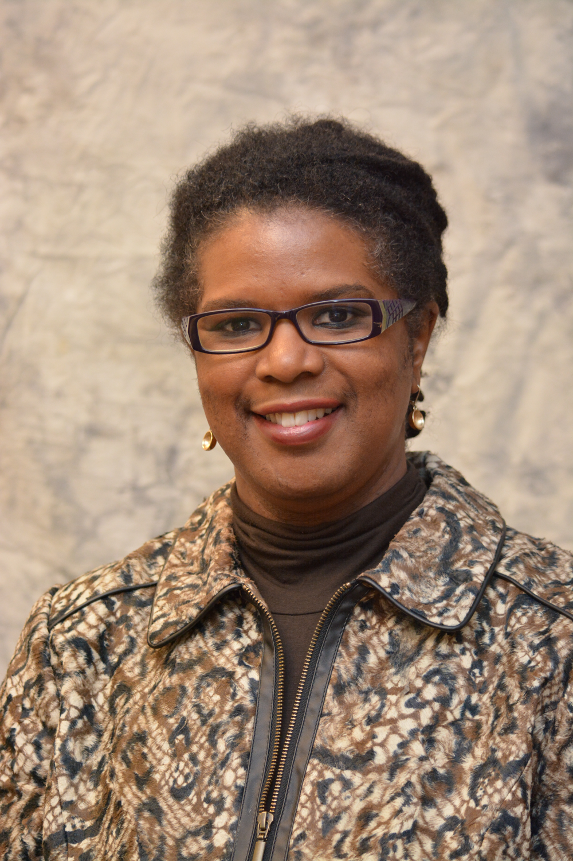 | Dianne Haulcy, Co-Chair  Voices and Choices for Children Coalition  Dianne Haulcy joined Think Small in 2015 as the Director of Family Engagement. Dianne has over 25 years of experience in the non-profit sector. In her history she has directed five early childhood programs all serving inner-city, low-income, ethnically diverse populations. She has overseen many human services programming in the areas of behavioral health; in-home parenting; youth outreach and out-of-school-time services; shelter and services to homeless families and individuals; and many other family and community programs.  Most recently she serves as Senior Policy Aide for Mayor Betsy Hodges working on issues of early childhood, education and youth. Part of her work includes spearheading the mayor’s Cradle to K Cabinet, focused on children prenatal to three years old to ensure they are ready for early childhood education opportunities.  Dianne has a BA in Sociology from Spelman College and an MA in Public Affairs from the Humphrey Institute at the University of Minnesota.
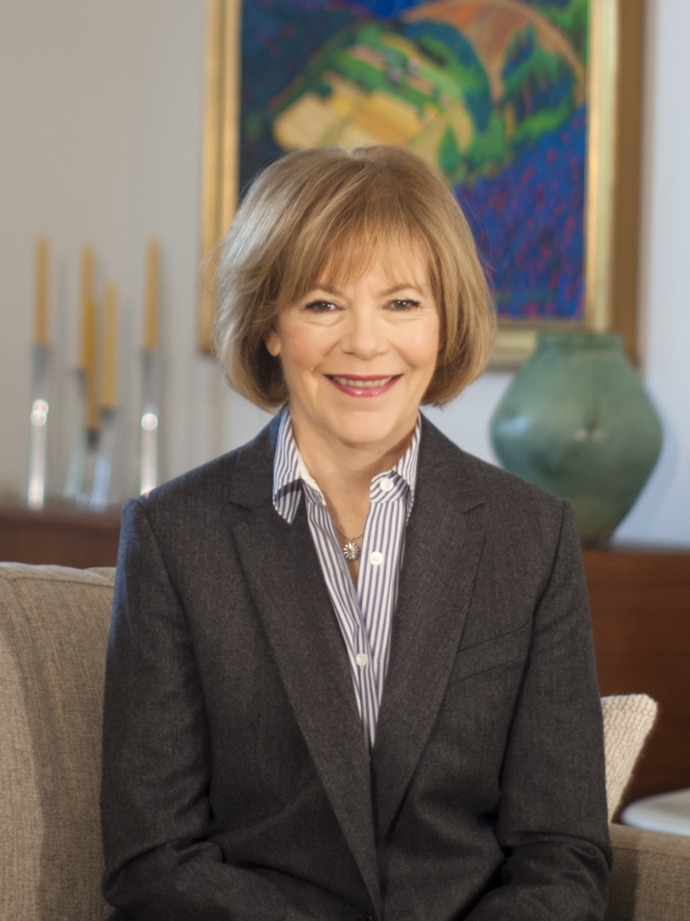 | Tina Smith, Lieutenant Governor  State of Minnesota  Tina Smith is Minnesota’s 48th Lt. Governor. Since taking office in January 2015, Tina has focused on building an economy that works for all Minnesotans – championing issues including rural broadband internet access, expanding access to early learning, and supporting statewide job creation.  Tina leads the Destination Medical Center initiative – a multi-billion dollar public-private partnership to make Rochester America’s City for Health. The DMC is expected to create 35,000 to 45,000 new jobs in southeast Minnesota, and attract over $5 billion in private investment over the next 20 years.  Before being elected Lt. Governor, Tina served as Governor Dayton’s Chief of Staff. In that role, she managed the daily operation of state government, an enterprise with 34,100 employees. Tina led the Administration’s Better Government Initiative to make government work better for people – speeding up permitting times, making government documents and forms easier to understand, and saving taxpayer money through more efficient, more customer-friendly services.
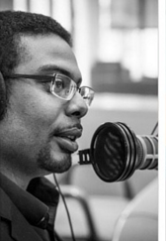 | Anthony Galloway, Student Program Lead  West Metro Education Program  Anthony Galloway serves as the student learning program lead and race equity coach for the West Metro Education Program. Anthony has worked in experiential learning and community engagement for over 15 years including work as an actor, musician, and storyteller. While Traveling to South Africa for the 10-year celebration of the election of Nelson Mandela, he was part of an American student delegation studying the effects of Apartheid on the new South Africa. It was here that he found a passion for multiple perspectives on race and ethnicity. Recently, he worked with Dr. Patrick Duffy to create a regional network of anti-racist student leaders, and the work is featured in a co-authored chapter in the book, More Courageous Conversations About Race (Singleton, 2012). Anthony Galloway is also a contributor to local organizations including Save our Sons juvenile detention alternative program, The Kamau Kambui Circle for Cultural Learning's Underground Railroad program, and MPR's "Counterstories" program on the Tom Webber Show.
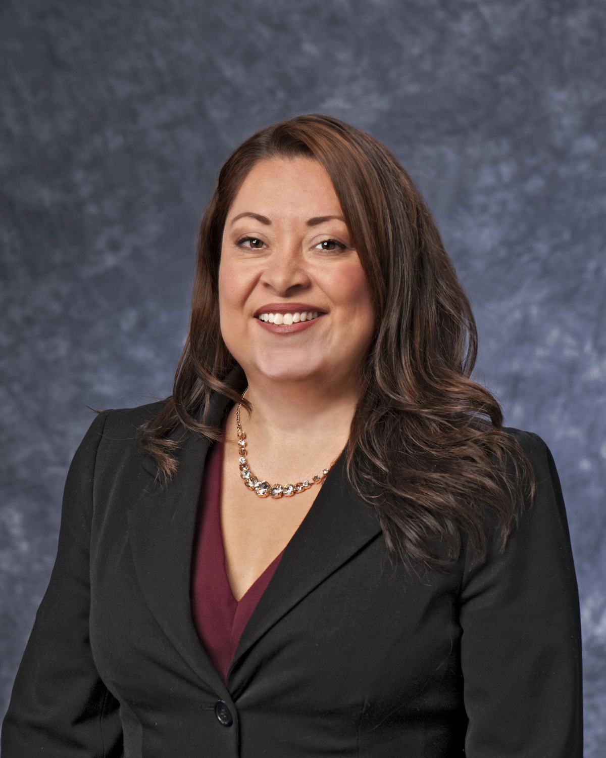 | Jennifer Godinez, Associate Executive Director  Minnesota Education Equity Program  As MnEEP Associate Executive Director, along with MnEEP collaborative partners, she co-leads the development of a policy brief series, a policy and advocacy fellowship program, and an advocacy campaign titled “5 Big Bold Goals” aimed at shaping equity and excellence transformation in Minnesota K12 schools and universities. Jennifer has also been the lead project director of the “Race Equity and Excellence in Education Network” (REEEN) initiative at MnEEP since 2011. REEEN works to build collective action teams to address race equity in education plans and leadership approaches in rural communities in Minnesota. She is an MnEEP representative on the Minnesota P20 Education Partnership Council led by the Minnesota Education Commissioner and state education leaders. Her chapter writings on race equity and teacher effectiveness have been featured in education journals and published in two publications by Stylus Publishing.
Barb Fabre, Director
White Earth Child Care Program

Barb Fabre, holds a Bachelor in Psychology and is an enrolled member of the Ojibwe Nation in Minnesota. She has worked for the White Earth Reservation for over 28 years; working within the Indian Child Welfare Program and Employment & Training Program. For the last 21 years, as Program Director of the Tribe’s Child Care & Early Childhood Programs. Ms. Fabre was the Chairperson of the National Indian Child Care Association for 7 years and co-founder of the Communities Collaborative Brain Development Conference (Minnesota’s largest brain development conference that attract over 800 parents, teachers, social workers and health professionals).

In 2014, she was appointed by Governor Dayton to his Minnesota Early Learning Advisory Committee and Governor Pawlenty to the new Guardian Ad Litem Advisory Board.

Barb is responsible for managing two child care centers, child care licensing program, child care assistance program, Race to the Top Scholarship Program, early childhood training program, parent mentoring program and initiating a tribal library and children’s interactive literacy exhibit.
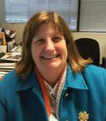 | Ann Marie DeGroot, Executive Director  Minneapolis Youth Coordinating Board  Ann Marie DeGroot has been the Executive Director of the Minneapolis Youth Coordinating Board since October 2008. She comes into her current position after serving 21 years as the founding Executive Director of OutFront Minnesota. In her role there she was instrumental in the passage of the 1993 Amendment to the Minnesota Human Rights Act which added legal protection for people regardless of sexual orientation and gender identity. In addition, she worked successfully with the Minnesota business community to add domestic partner benefits for couples in same gender relationships and was intimately involved in defeating efforts to pass a constitutional amendment which would ban the legal recognition of same gender relationships.  Ann serves as the Chair of the Board of Athlos Leadership Academy, a Minnesota Charter School. Additionally, Ann is a founding member of the Minnesota Alliance for Progressive Action and CenterLink: The Community of LGBT Centers. She is a former board member of the Headwaters Foundation for Justice and the Greater Minneapolis Girl Scout Council. Ann has presented at numerous conferences on topics as diverse as board development, fundraising, the role of the Executive Director, tax issues for non-profit organizations, how to set up a fiscal sponsorship program, class and age issues in community organizing and electoral strategies for non-profit organizations.
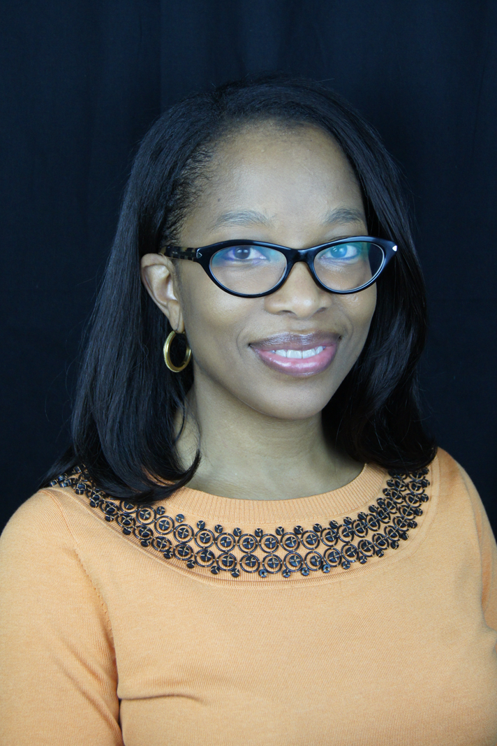 | Dr. Kimberly Matier, Executive Director  West Metro Education Program  Dr. Kimberly Matier comes to West Metro Education Program with over 17 years of experience as an educator. She has most recently served as Deputy Chief Academic Officer for Minneapolis Public Schools. Prior to joining MPS, she served as PK-12 Director of Instruction, Curriculum and Assessment for Portland (OR) Public Schools which served 95 school sites, community based organizations, and alternative school programs. It was there she established herself as an educational equity leader by developing the district equity and strategic frameworks for accelerating student outcomes, enhancing the RTI framework to address achievement disparities as well as promote cultural and linguistic responsiveness to meet district equity key performance indicators in talented and gifted program for underrepresented populations.
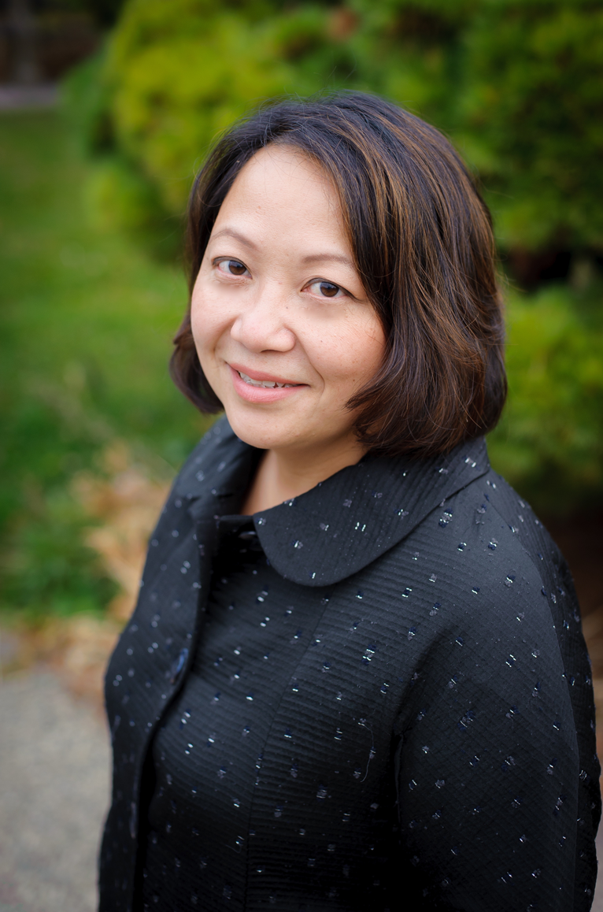 | Bo Thao Urabe, Network Director  Coalition of Asian American Leaders  Bo Thao-Urabe is a social entrepreneur focused on creating community-centered, asset-based solutions that result in meaningful progress for those who are most impacted. Bo currently serves as Network Director for the Coalition of Asian American Leaders (CAAL), which brings cross-sector, cross-generational, and cross-ethnic leaders together to advance equity to improve the lives of Asian Minnesotans. Bo also serves as a Commissioner to President Obama's Advisory Commission on Asian Americans and Pacific Islanders. She is one of the few people in Minnesota with the honor of having the same day named after her in both the City of Saint Paul and the State of Minnesota.
Kleber Ortiz-Sinchi, Social Studies Content Lead
Minneapolis Public Schools

Kleber Ortiz-Sinchi was born in Ecuador and migrated to the US when he was 10 years old. He is a product of the MPS schools system and received his BA from the University of Minnesota and his Masters in Education from Augsburg College. He has worked as an after school coordinator, family liaison, associate educator, and teacher. He taught high school, middle school and now he works as the 6-12 Social Studies District Program Facilitator for MPS. Kleber is a proud father of two children.

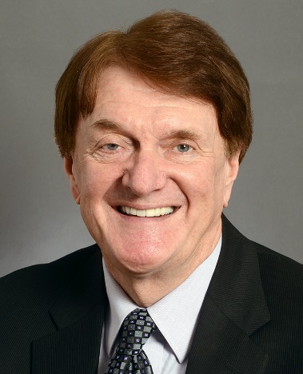 | Charles Wiger, Education Finance Committee Chair  Minnesota Senate  Charles "Chuck" Wiger is a Minnesota politician and member of the Minnesota Senate. A member of the Minnesota DFL Party, he represents District 43, which includes portions of Ramsey and Washington counties in the northeastern Twin Cities metropolitan area.
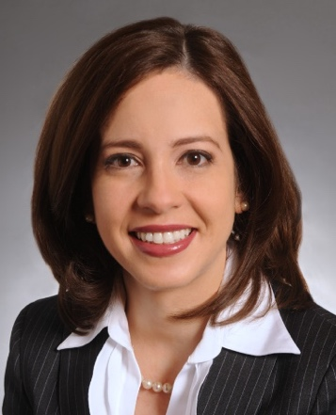 | Melissa Franzen, Health and Human Services Finance Committee  Minnesota Senate  Melisa Franzen is a Minnesota politician and a member of the Minnesota Senate. A member of the Minnesota DFL Party, she represents District 49 in the southwest Twin Cities metropolitan area. Franzen is also an attorney and small business owner.
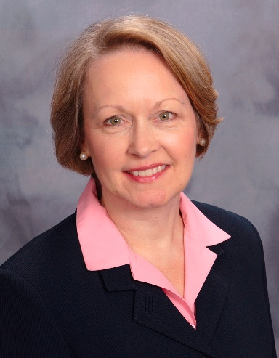 | Jenifer Loon, Education Finance Committee Chair  Minnesota House of Representatives  Jenifer W. Loon is a Minnesota politician serving in her fourth term as a State Representative. A member of the Republican Party of Minnesota, she represents District 48B, which lies primarily in Eden Prairie in southwestern Hennepin County in the Twin Cities metropolitan area. Loon is also a legislative policy consultant.
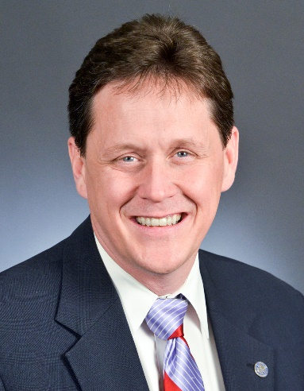 | Matt Dean, Health and Human Services Finance Committee  Minnesota House of Representatives  Matt Dean is a Minnesota politician serving in his sixth term as State Representative. He served as the Majority Leader of the Minnesota House of Representatives from 2011 to 2013. A member of the Republican Party of Minnesota, he represents District 38B, which includes all or portions of Ramsey and Washington counties in the eastern Twin Cities metropolitan area. He is an architect and the owner of Dean Architects in Dellwood.
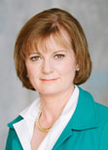 | Sarah Caruso, President and CEO  Greater Twins Cities United Way  Sarah Caruso has been Chief Executive Officer and President of Greater Twin Cities United Way since November 30, 2009. Ms. Caruso has worked with the Board of Directors and Staff to insure the strategic goals of the Agenda for Lasting Change are achieved. Much of her work is externally oriented with donors, volunteers, public policy leaders and agency partners. Internally, she works with the leadership team to set and meet annual goals, as well as assure a strong, positive work environment for all staff, volunteers, board and agency partners. Most recently, she served as president of Minnesota Children's Museum from 2004 to November 13, 2009. Prior to that, she led a boutique consulting firm, Northampton Partners, and worked for General Mills in brand management and strategic business functions. She also serves as Chairman of the Council on Early Care and Education, appointed by Governor Pawlenty at the council's inception in December 2008. She has served on a variety of nonprofit boards including: National Association of Children's Museums, Arc Greater Twin Cites, Minnesota State Arts Board, The Children's Theatre Company and Pacer Center. She has a Masters in Business Administration from Stanford University and a Bachelor of Arts with high honors in economics from Smith College.

