12th Annual Nancy Latimer Convening for Children & Youth
2018 “Nancy” Award Honoree

Nancy Jost
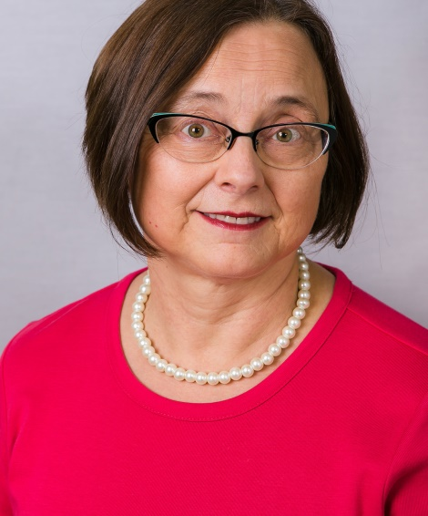

Nancy Jost is the Director of Early Childhood for West Central Initiative, a regional community foundation serving nine counties in west central Minnesota.

She oversees 10 Early Childhood Initiatives in the region, as well as the Early Childhood Dental Network and Early Childhood Mental Health Network.

Nancy works to increase communication and partnership between early childhood stakeholders. As an advocate for quality early childhood care, education and policy development, she serves on several statewide committees and is the chair of Governor Dayton’s Early Learning Council.

2018 Special Recognition Award Recipients
Mina Thao
Parent Advocate

Mina is the mother of four children, her eldest a first grader in the Saint Paul school district. She became interested in advocacy as she gained knowledge and confidence through home visiting and parenting classes at Way To Grow, where several of her children have attended the Preschool Pals early childhood program. She has seen first hand the importance of being involved and speaking up on behalf of her children in schools. Mina has also been actively sharing her story with legislators, community leaders and other parents to advocate for increased funding to high quality programs for more of Minnesota’s young children.

Senator Justin Eichorn
Senator Justin Eichorn attended Grand Rapids High School, graduating in 2003. He then attended Itasca Community College for general education and completed a Bachelor of Arts degree in Organizational Management and Leadership in 2013 from Concordia University St. Paul.

Justin and his wife Brittany have been married for 10 years and have 4 children. Outside of his public service, Justin is an entrepreneur having worked in the retail and housing sectors. Justin enjoys northern Minnesota for its great outdoor recreation opportunities and believes it is a wonderful place to raise a family.

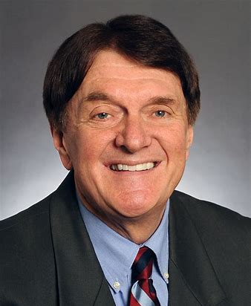
Senator Charles Wiger
Senator Wiger has five children, and five grandchildren, and lives in Maplewood. He is a practicing attorney, and before he joined the Senate, he managed several area chambers of commerce.
Senator Wiger is currently the chair of the E12 Finance Division. He has been active in education policy issues since he was 21, when he was first elected to the District 622 Board (completing seven terms and his final term as board chair.) Senator Wiger also served as a supervisor and chair on the Ramsey County Soil and Water Conservation District Board. From 1983 TO 1989, he served as a member of the Metropolitan Council.

